## MATLAB CODE

%% Experiment 1 - Pendulum Over a Cart

% Tanmay Alias Manjeet Vilas Samak (RA1711018010101)

% Initialization

clc;

clear all;

close all;

% System Parameters

M = 0.5; % Mass of Cart (kg)

m = 0.2; % Mass of Pendulum (kg)

b = 0.1; % Friction/Damping Coefficient (N/m/s)

g = 9.8; % Gravity (m/s^2)

l = 0.3; % Length of Pendulum (m)

I = 0.006; % Inertia (kg.m^2)

%% Task 1 - System Representation

% Transfer Function Representation

s = tf('s');

q = (M+m)*(I+m*l^2)-(m*l)^2;

P_cart = (((I+m*l^2)/q)*s^2-(m*g*l/q))/(s^4+(b*(I+m*l^2))*s^3/q-((M+m)*m*g*l)*s^2/q-b*m*g*l*s/q);

P_pend = (m*l*s/q)/(s^3+(b*(I+m*l^2))*s^2/q-((M+m)*m*g*l)*s/q-b*m*g*l/q);

sys_tf = [P_cart;P_pend];

inputs = {'u'};

outputs = {'x';'phi'};

set(sys_tf,'InputName',inputs)

set(sys_tf,'OutputName',outputs)

sys_tf

% State Space Representation

p = I*(M+m)+M*m*l^2;

A = [0 1 0 0;

0 -(I+m*l^2)*b/p (m^2*g*l^2)/p 0;

0 0 0 1;

0 -(m*l*b)/p m*g*l*(M+m)/p 0];

B = [0;

(I+m*l^2)/p;

0;

m*l/p];

C = [1 0 0 0;

0 0 1 0];

D = [0;

0];

states = {'x' 'x_dot' 'phi' 'phi_dot'};

inputs = {'u'};

outputs = {'x';'phi'};

sys_ss = ss(A,B,C,D,'statename',states,'InputName',inputs,'OutputName',outputs)

%% Task 2 - Open Loop System Response

t = 0:0.01:10;

figure

impulse(sys_tf,t) % Impulse Response

figure

step(sys_tf,t) % Step Response

%% Task 3 - PID Controller

Kp = input('Enter Kp Value: '); % 100

Ki = input('Enter Ki Value: '); % 1

Kd = input('Enter Kd Value: '); % 20

ctrl = pid(Kp,Ki,Kd);

sys = feedback(P_pend,ctrl)

figure

impulse(sys) % Impulse Response

## RESULTS

1. The differential equations representing the inverted pendulum over cart were formulated and the transfer function as well as state space representations of the system were programmatically written in MATLAB.
2. The open loop impulse as well as step responses of the system (inverted pendulum over cart) indicated that the system is inherently unstable (since it does not follow the bounded-input-bounded-output or BIBO criterion for stability) and that an external controller is necessary for achieving system stability, tracking and robustness.

|  |  |
| --- | --- |
|  |  |

1. A simple PID controller was designed for making the system stable and the closed loop response of the system was analysed in order to check whether the BIBO criterion for stability was met. PID controller gains Kp, Ki and Kd were manipulated to get a stable system response. The final controller gains were noted to be 100, 1 and 20 for Kp, Ki and Kd respectively, for which the closed loop system response was bounded between 0 and 0.045 thereby satisfying the BIBO criterion for stability with minimal steady state error.

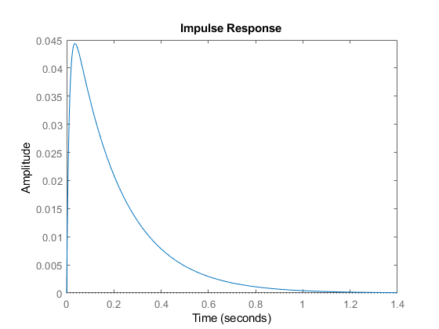

## LAB SESSION SCREENSHOT

## 

## INFERENCE

This experiment gave a deeper understanding about modeling and simulation of dynamic systems using a case study of an inverted pendulum over cart, which is a typical mechatronics-based design approach. Moreover, implementation of a PID controller with closed loop system response analysis was also covered in this experiment which gave an idea about practical control system design problem and analysis of controlled behavior of a system. Furthermore, this experiment also helped familiarize with the world’s most widely used software product for the purpose – MATLAB.

From this experiment, it is evident that MATLAB is a very powerful tool when it comes to study and analysis of dynamic systems (both open and closed loop system behavior), such as an inverted pendulum over cart modeled and simulated in this exercise. It provides a range of built-in functions and toolboxes for rapid system analysis across multiple representation types (including transfer function as well as state space models). Furthermore, MATLAB is also very powerful software for control system design and offers multiple tools for fast and convenient testing.